# CS 255 System Design Document Template

Stefan Land

## UML Diagrams

### UML Use Case Diagram

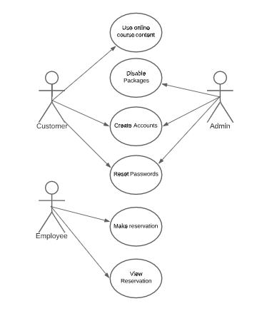

### UML Activity Diagrams

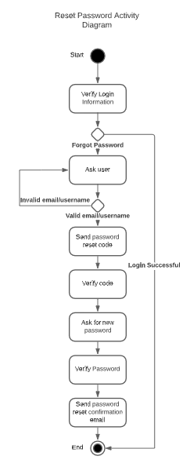

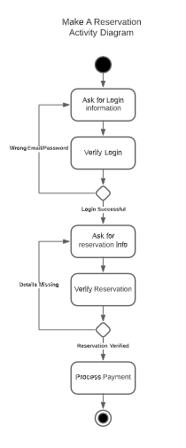

### UML Sequence Diagram

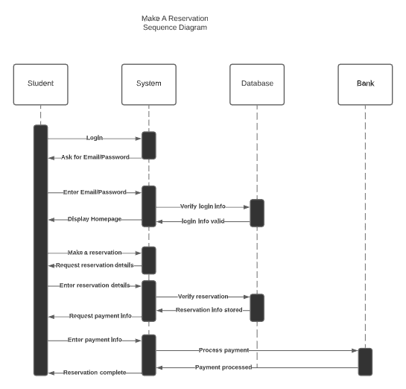

### UML Class Diagram

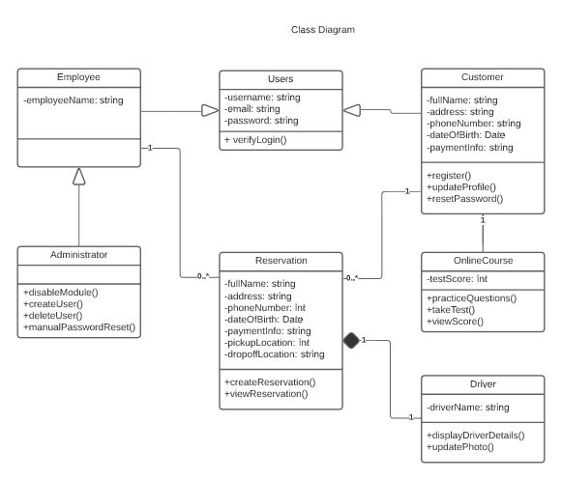

## Technical Requirements

Hardware:

* A computer with internet access. The system will be run on remote cloud servers. The user will just need a device capable of connecting to the internet to access the virtual machines that run the server.

Software:

* A web browser to access the virtual machines.

Geographic Information:

* The server will not be located physically on the premises. It will be provided my Microsoft’s cloud service, Azure.